LAB S3 WITH TERRAFORM IAM

Q-1 In this lab, we will work on configuration directories that have been created under /root/terraform-projects/S3-Buckets.
A-1 Ok.

Q-2 Let's first inspect the configuration files in the directory called MCU.
What is the AWS region configured for use in the provider block? (Assuming we do not pass in additional variables during command execution)
A-2 look in terraform.tfvars file , region is “us-east-1”

Q-3
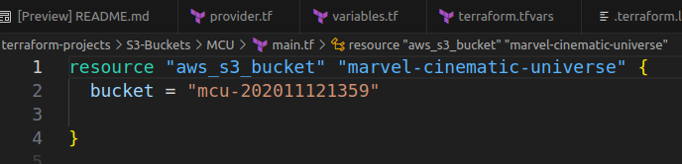
There is a resource block configured in the main.tf file in this configuration directory. What is the resource name that will be provisioned when we run terraform apply?
A-3 “marvel-cinematic-universe”

Q-4
What is the current state of this configuration directory?
A-4
Resources are Provisioned
Check terraform.tfstate file , you will see the S3 Bucket is Provisioned.

Q-5
What is the name of the s3 bucket that has been created by this configuration?
A-5
Look in main.tf , bucket – “mcu-202011121359”
This is Bucket Name

Q-6
What is the DNS domain name that is created for this bucket?
A-6 “mcu-202011121359.s3.amazonaws.com”
Look into .tfstate file & find attributer bucket_domain_name.
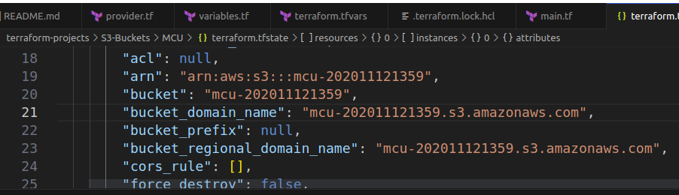

Q-7 Now, let's move on and work on a different configuration directory called DC.
A-7 Ok

Q-8
The main.tf file is empty. Use it to create a new S3 with the following specifications:
resource name: dc_bucket
bucket name: dc_is_better_than_marvel
Once the resource block is complete, run a terraform init, plan and apply to try and create the bucket.

If unsure, refer to the documentation. The documentation tab is available at the top right panel.
(it's ok if you get an error! Move on to the next question!)
A-8 I created s3 resource block & give arguments as per requirement, but terraform plan is run successful , but terraform apply give error, bcz, bucket name is not match to std syntax like Not Allow space , _ , Capiltal Letter etc in bucket name.
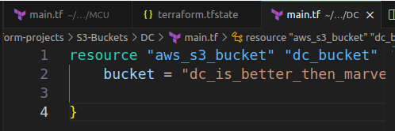

Q-9
Why did the terraform apply command fail?
A-9 Invalid Bucket Name

Q-10
That's right! The bucket name we used does not conform to a DNS Name standard as it uses underscores.
A-10 Ok

Q-11
Let's fix that now and change the bucket name so that it uses dashes (-) instead of underscore(_).
resource name: dc_bucket
bucket name: dc-is-better-than-marvel
Once the resource block is complete, run a terraform init, plan and apply to try and create the bucket.

A-11
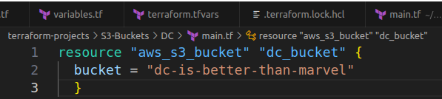

Q-12
Let's move on to the next configuration directory called Pixar.
Same as the directory called DC, we have the provider.tf, variables.tf, terraform.tfvars and an empty main.tf file that is already created.
A-12 Ok
Q-13
We have a file called woody.jpg stored at /root that has to be uploaded to a bucket called pixar-studios-2020. This bucket already exists though and was created using the AWS CLI.
A-13
Ok
Q-14 Let's do that now and upload this image to the s3 bucket! Update the main.tf file with the following specifications:
- Bucket: pixar-studios-2020
- Key: woody.jpg
- Source: /root/woody.jpg
- Use object (resource) Name: upload
Once ready, proceed to run terraform init, plan and apply.
A-14
